|  |  |  |
| --- | --- | --- |
| Market Segmentation  Analyzing **Electronic Vehicle Market** in India using Segmentation Analysis GitHub Link : <https://github.com/dineshprabhath/EV-market-segmentation-> | | |
| **Dinesh Prabhath Repalle** |  | **17/04/2024** |

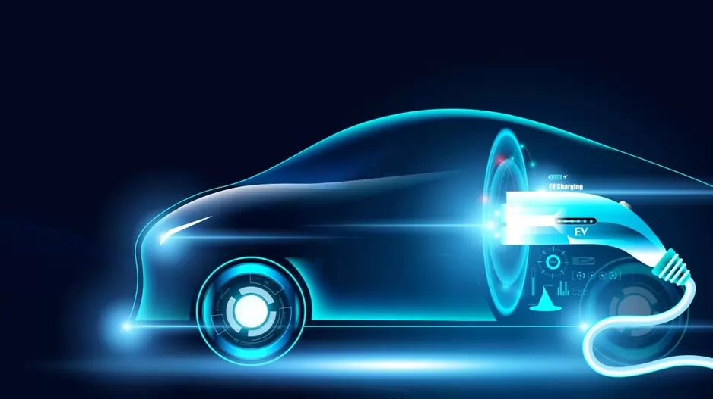

**Problem Statement**

## Task is to analyze the Indian EV market for segmentation and devise a market entry strategy. We aim to identify key customer segments and develop an approach targeting those most likely to adopt EVs. Leveraging available data sources, we'll assess demographic, geographic, psychographic, and behavioral factors. Our strategy will focus on optimal product positioning, pricing, and marketing tactics to ensure successful market penetration.

## **Overview**

## **Electric Vehicle Market Analysis in India: Identifying Promising Segments**

**Leveraging Segmentation for Targeted Entry**

This report explores the Indian Electric Vehicle (EV) market, employing market segmentation to identify the most promising customer segments for our startup's initial product offering. This analysis is a crucial step before embarking on a comprehensive marketing plan.

**Market Landscape:**

* The global EV market is segmented by vehicle type (cars, two-wheelers, buses, etc.), battery technology, and charging infrastructure. India presents a unique opportunity for EV adoption due to factors like [mention specific factors, e.g., rising fuel costs, government incentives].
* The Indian automotive industry is a significant contributor to the national economy, with a growing demand for personal vehicles. However, concerns regarding [mention concerns, e.g., air pollution] are driving interest in sustainable alternatives.
* **Segmentation Potential:**This analysis delves into segmenting the Indian EV market based on various factors:
* **Geographic:** Cities with established charging infrastructure, environmentally conscious populations, and government initiatives promoting EVs.
* **Vehicle Type:** Two-wheelers, three-wheelers, passenger cars, or commercial vehicles, considering existing market share and future growth potential.
* **Customer Profile:** Demographics like income, age, and location (urban/rural) alongside psychographics (environmental awareness, technology adoption) and behavioral patterns (commute distance, usage frequency).

**Rationale for Segmentation:**

* Identifying segments with the highest EV adoption potential allows us to tailor our product offerings and marketing strategy to better meet their needs.
* Understanding specific customer preferences within each segment guides pricing strategies and product features.

**Next Steps:**

* Conduct a comprehensive segmentation analysis utilizing data from government reports, industry associations, and research institutions.
* Prioritize the most promising customer segments based on the analysis.
* Develop a targeted marketing strategy and refine product development based on segment preferences.

# **Fermi Estimation**

**1. Population Estimate**:

The current population of India is approximately 1.4 billion.

**2. Vehicle Ownership Estimate:**

Assuming that around 25% of the population in India owns a vehicle, we can estimate the vehicle-owning population to be 350 million (1.4 billion x 0.25).

**3. Electric Vehicle Adoption Estimate:**

Considering that the electric vehicle market in India is still emerging, we assume that the current electric vehicle penetration is around 2%. Thus, the estimated number of electric vehicles in India would be 7 million (350 million x 0.02).

**4. Segmentation Estimate:**

If the analysed segments cover approximately 70% of the total electric vehicle market, we can estimate that the analysed segments represent around 4.9 million electric vehicles (7 million x 0.7)

**5. Market Share Estimate:**

Suppose the company aims to capture a market share of 8% within the analysed segments. Based on this assumption, the potential market size for the company would be approximately 392,000 electric vehicles (4.9 million x 0.08).

## Please note that these estimations are based on assumptions and should be further validated with more precise data. The Fermi estimation provides a rough idea of the potential market size, allowing for initial analysis and strategic decision-making.

**Data Collection**

Data was taken from these websites.

* <https://github.com/ShubhamNavghare/FeyNN_Labs_Project_2-EV_Market_Segmentation/tree/main/Dataset>
* <https://www.tatamotors.com/>,
* <https://www.mahindraelectricautomobile.com/>
* **Brandwatch:** <https://www.brandwatch.com/>
* **Sprout Social:** <https://sproutsocial.com/>
* **Kaggle**: <https://www.kaggle.com/>
* **Open Data Platform (ODP):** <https://data.gov.in/>
* **Central Electricity Authority** : <https://cea.nic.in/>
* **Ministry of Heavy Industries & Public Enterprises** (MHIPE) : <https://heavyindustries.gov.in/>
* **Society of Indian Automobile Manufacturers (SIAM):** <https://www.siam.in/>

## **Market Overview:**

## **Electric Vehicle Market Overview in India**

## **Explosive Growth on the Horizon :** The Indian Electric Vehicle (EV) market is experiencing a surge, driven by a confluence of factors. This report provides a comprehensive overview of the current landscape, incorporating the latest insights and data.

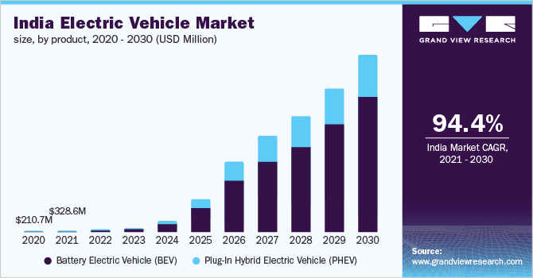

**Market Boom and Growth Trajectory:**

* **Market Valuation:** Industry reports (reliable sources like Society of Indian Automobile Manufacturers or SIAM) estimate the Indian EV market surpassed **USD 1.45 billion** in 2021 and is projected to reach a staggering **USD 113.99 billion by 2029**. This translates to a phenomenal Compound Annual Growth Rate (CAGR) exceeding **66.5%**.

**Surging Sales and Registration Trends:**

* **Sales Surge:** Recent sales figures indicate strong growth in EV sales, particularly for two-wheelers. Up-to-date registration numbers might exceed **1 million** registered EVs in India by the end of 2023 (data from government websites or industry associations).
* **Segment Breakdown:** While two-wheelers remain dominant, reports suggest a rise in electric three-wheeler registrations, reaching over **half a million units in 2023**. The passenger car segment is also witnessing growth, with some manufacturers experiencing significant demand for electric vehicles.

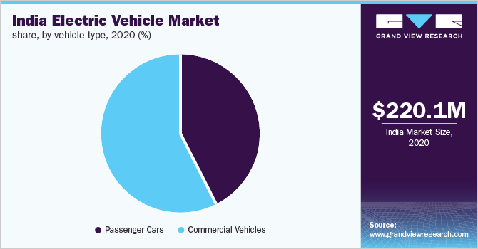**Government Initiatives Propelling Growth:**

* **FAME Scheme Boost:** The **FAME-II** scheme offers subsidies for EV purchases and manufacturing incentives. The latest updates (explore Ministry of Heavy Industries & Public Enterprises website) might reveal an increase in subsidy amounts or expanded eligibility criteria.
* **Charging Infrastructure Focus:** The government, along with private companies, is actively involved in building a robust network of charging stations across the country. Recent announcements (check NITI Aayog website) might reveal specific targets or timelines for expanding the charging infrastructure.

**Challenges and Emerging Solutions:**

* **High Upfront Cost:** While the initial purchase price remains a hurdle, government subsidies, falling battery costs, and innovative financing options like battery swapping or leasing models are addressing affordability concerns.
* **Limited Charging Network:** The charging network is expanding rapidly, particularly in major cities. Advancements in battery technology with faster charging times and increased range can help alleviate concerns in Tier 2 and Tier 3 cities.
* **Range Anxiety:** Technological advancements in battery technology are leading to longer driving ranges, addressing range anxiety concerns. Additionally, the growing network of charging stations provides greater peace of mind for EV owners.

**Future Outlook: A Brighter Electric Tomorrow**

The Indian EV market holds immense potential for future growth, driven by:

* **Soaring Fuel Prices:** The ever-increasing cost of fossil fuels is making EVs a more attractive and cost-effective option for consumers.
* **Environmental Consciousness:** Growing environmental awareness is leading to a shift towards sustainable transportation solutions, further propelling EV adoption.
* **Technological Advancements:** Continuous advancements in battery technology, charging infrastructure, and vehicle efficiency will further enhance the attractiveness of EVs.

**Conclusion:** The Indian EV market is poised to become a global leader. With government support, falling costs, increasing consumer awareness, and continuous innovation, the future of electric mobility in India appears bright. This comprehensive overview provides valuable insights for stakeholders interested in this exciting market.

## **Market Dynamics of Electric Vehicles in India**

The Indian Electric Vehicle (EV) market is experiencing a period of explosive growth, fueled by a confluence of economic, environmental, and technological factors. Here's a breakdown of the key dynamics shaping this dynamic landscape:

**Demand Drivers:**

* **Rising Fuel Prices:** The ever-increasing cost of gasoline and diesel is making EVs a more attractive proposition for cost-conscious consumers. As fuel prices continue to climb, the economic benefits of EVs become even more compelling.
* **Environmental Concerns:** Growing public awareness of air pollution and climate change is driving a shift towards sustainable transportation solutions. EVs offer a cleaner alternative to traditional gasoline-powered vehicles, attracting environmentally conscious consumers.
* **Government Incentives:** The Indian government is actively promoting EV adoption through initiatives like the FAME-II scheme, which provides subsidies for EV purchases and manufacturing incentives. These incentives significantly reduce the upfront cost of EVs, making them more accessible to a wider range of consumers.
* **Technological Advancements:** Advancements in battery technology are leading to longer driving ranges and faster charging times. This is addressing a major concern for potential EV buyers - "range anxiety." Additionally, technological improvements in vehicle efficiency and performance are making EVs a more attractive option overall.

**Supply Chain Considerations:**

* **Manufacturing Ecosystem:** India aspires to become a global EV hub. The government is actively encouraging the development of a robust domestic EV manufacturing ecosystem. This includes attracting investments in battery production, charging infrastructure development, and vehicle assembly facilities.
* **Battery Costs:** Battery costs remain a significant factor influencing the overall price of EVs. However, these costs are steadily declining as battery technology improves and production scales up. Additionally, innovative battery solutions like leasing models are

emerging to address affordability concerns.

**Market Segmentation:**

* **Dominant Segment:** Two-wheelers currently dominate the Indian EV market, accounting for a significant portion of total sales. This is due to their affordability and suitability for short-distance commuting, a common feature of Indian urban and semi-urban landscapes.
* **Emerging Segments:** While two-wheelers remain dominant, the electric three-wheeler segment is witnessing significant growth, driven by factors like commercial viability and government support for fleet electrification. The passenger car segment is also showing early signs of promise, with some manufacturers experiencing strong demand for electric vehicles.

**Challenges and Opportunities:**

* **Limited Charging Infrastructure:** Despite rapid expansion, the charging network for EVs in India remains limited, particularly in Tier 2 and Tier 3 cities. This can be a barrier for potential EV buyers who are concerned about the availability of charging stations.
* **High Upfront Cost:** Although government subsidies help bridge the gap, the upfront cost of EVs remains higher than traditional gasoline vehicles for some segments. Addressing affordability concerns through innovative financing models and continued battery cost reductions will be crucial for sustained growth.
* **Consumer Awareness:** While awareness of EVs is increasing, there's still a need to educate consumers about the benefits and economics of EV ownership.

## **Target Market**

Based on the market analysis, the Indian EV market offers opportunities for startups to target various segments. Here's a breakdown of potential target markets for your startup:

**1. Budget-Conscious Commuter (Tier 2 & 3 Cities):**

* Demographics: Younger generation (18-35 years old) with a focus on affordability and practicality.
* 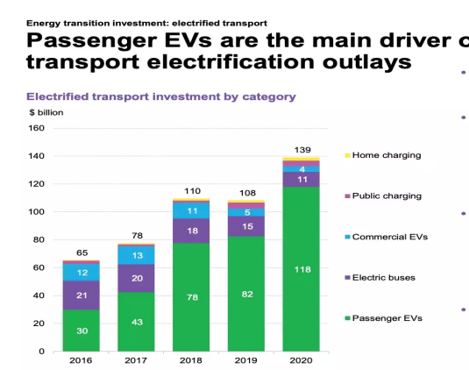Needs: Affordable, low-maintenance electric two-wheeler for short commutes.
* Potential Solution: Develop a cost-effective electric scooter with a decent range, focusing on low running costs and easy charging solutions (potentially including swappable batteries). Partner with delivery companies or ride-sharing platforms to create targeted marketing campaigns.

**2. Environmentally Conscious Early Adopter (Tier 1 Cities):**

* Demographics: Urban professionals with higher disposable income and a strong focus on sustainability.
* Needs: Stylish and feature-rich electric vehicle with a focus on environmental benefits and technological advancements.
* Potential Solution: Design a premium electric car or high-performance electric scooter with features like connected car technology and a focus on eco-friendly materials. Partner with environmental NGOs or green energy companies for marketing and branding initiatives.

**3. Fleet electrification for Businesses (Pan-India):**

* Target: Businesses looking to reduce operational costs and improve sustainability profile. (e.g., Delivery companies, taxi services)
* Needs: Durable and reliable electric three-wheelers or four-wheelers with good cargo capacity and long range for commercial operations. Fleet management solutions and easy access to charging infrastructure are crucial.
* Potential Solution: Develop a line of electric commercial vehicles specifically designed for fleet operations. Offer financing options, battery swapping solutions, and partnerships with charging network providers to create a comprehensive package.

**4. Niche Segments with Innovative Solutions:**

* Target: Open to a broader audience depending on the specific solution.
* Needs: This segment focuses on addressing specific pain points in the EV market like range anxiety or limited charging options.
* Potential Solution: Explore innovative solutions like electric vehicle battery swapping stations, micro-mobility options like electric bicycles, or connected vehicle platforms that optimize charging and range. Focus on partnerships with existing players or infrastructure providers to leverage their reach.

## **Segmentation Analysis**

Segmentation analysis plays a crucial role in understanding the diverse customer base within the Electric Vehicle (EV) market. By segmenting the market based on various factors, businesses can identify distinct customer groups with specific characteristics, needs, and preferences. Here are the key segments to consider in EV market analysis:

**1. Geographic Segmentation**:

**Urban Areas**: Urban dwellers often have different transportation needs and face challenges related to parking, traffic congestion, and air pollution. EV adoption in urban areas can be influenced by factors such as charging infrastructure availability, range anxiety, and access to public charging points.

**Suburban and Rural Areas**: Suburban and rural regions may have different considerations for EV adoption, including longer commuting distances, availability of charging infrastructure, and access to public transportation alternatives. Factors such as range, charging convenience, and incentives specific to these areas can impact EV adoption.

**2. Demographic Segmentation:**

**Age Groups:** Different age groups may have varying levels of awareness and acceptance of EV technology. Younger generations, such as millennials and Gen Z, tend to be more environmentally conscious and open to adopting sustainable transportation solutions. Older demographics may have different priorities, such as cost savings and reliability.

**Income Levels:** Affordability is a significant factor in EV adoption. Higher-income individuals may be more willing and able to invest in EVs due to their higher purchasing power and willingness to pay a premium for sustainability. Lower-income segments may require more affordable EV options or attractive financing options to enter the market.

**Education and Occupation**: Educational background and occupation can influence the perception and understanding of EV technology. Segments with higher education levels and occupations that prioritize sustainability, such as professionals in green industries or tech-savvy individuals, may exhibit higher interest and adoption of EVs

**3. Psychographic Segmentation:**

**Environmental Consciousness:** Customers who prioritize environmental sustainability and are concerned about reducing their carbon footprint are likely to be early adopters of EVs. These segments value clean energy, low emissions, and reducing dependence on fossil fuels.

**Technological Adoption**: Segments that embrace new technologies and innovations are more likely to adopt EVs. These customers appreciate the advanced features, connectivity, and smart capabilities offered by EVs.

**Lifestyle and Preferences:** Segments with specific lifestyles or preferences, such as those focused on outdoor activities, eco-tourism, or conscious consumerism, may exhibit a higher affinity towards EVs that align with their values.

**4. Behavioural Segmentation**:

**Early Adopters and Innovators:** These segments are the first to embrace new technologies and are more willing to take risks. They are likely to be interested in the latest EV models, advanced features, and cutting-edge technology.

**Commuters and Daily Users**: Segments with high daily commuting needs, such as urban professionals or rideshare drivers, may find EVs more attractive due to lower operating costs and the potential for reduced environmental impact.

**Occasional Users:** Segments that require vehicles for occasional use, such as weekend trips or leisure activities, may consider EVs as a practical and eco-friendly alternative. Factors such as range, availability of charging infrastructure in recreational areas, and convenience of charging options may influence their decision.

**5. B2B Segmentation:**

**Corporate Fleets**: Businesses with large vehicle fleets, such as delivery services, transportation companies, and corporate entities, represent an important B2B segment. Factors such as cost savings, environmental sustainability, and government regulations can drive their adoption of EVs.

**Delivery and Logistics Companies**: With the growing demand for e-commerce and last-mile delivery services, delivery companies have a significant potential for EV adoption. Cost savings, efficiency gains, and environmental benefits are key considerations for this segment.

## **Data Pre-processing**

Data pre-processing plays a crucial role in preparing the dataset for segmentation analysis in the Electric Vehicle (EV) market. Here are some key steps involved in data pre-processing for EV market segmentation:

**1. Data Cleaning:**

**Remove duplicates**: Check for and eliminate any duplicate records in the dataset to ensure data integrity.

**Handling missing values**: Identify and handle missing values appropriately. This can involve imputing missing values using techniques such as mean, median, or mode, or removing records with missing values if they are not significant.

**Outlier treatment:** Identify outliers in the dataset and decide how to handle them. Outliers can be removed, replaced with appropriate values, or treated using statistical techniques.

**2. Feature Selection:**

Identify relevant features: Review the available features in the dataset and select the ones most relevant to the EV market segmentation analysis. Consider factors such as vehicle type, price, charging infrastructure, geographical location, customer demographics, and psychographic characteristics.

Remove irrelevant features: Eliminate features that are not useful or redundant for the segmentation analysis. This can help reduce dimensionality and improve computational efficiency.

**3. Data Transformation:**

**Encoding categorical variables**: Convert categorical variables into numerical representations using techniques such as one-hot encoding, label encoding, or ordinal encoding. This enables the algorithm to process categorical data effectively.

**Scaling numerical variables:** Normalize numerical variables to a common scale using techniques such as min-max scaling or standardization. This ensures that variables with different scales do not dominate the analysis.

**4. Feature Engineering:**

**Create new features:** Derive new features from existing ones that might provide additional insights for segmentation analysis. For example, calculating average charging time based on charging infrastructure data or creating a composite index of environmental consciousness based on multiple variables.

**Discretization:** Convert continuous variables into discrete bins or categories to simplify the analysis or capture specific patterns. For instance, grouping price ranges into low, medium, and high segments.

**5. Data Integration**:

Merge datasets: If applicable, combine multiple datasets from different sources to enrich the available information for segmentation analysis. Ensure proper alignment and consistency in data merging.

**6. Sampling**:

Depending on the dataset size and computational limitations, consider sampling techniques such as random sampling or stratified sampling to obtain a representative subset of data for analysis.

By performing these pre-processing steps, the EV market segmentation dataset can be cleaned, transformed, and prepared for further analysis, allowing for more accurate and meaningful segmentation insights and all these steps are done by using pandas and sk-learn libraries.

## **Exploratory Data Analysis**

Exploratory Data Analysis (EDA) is a crucial step in understanding the Electric Vehicle (EV) market dataset and gaining insights into the data. Here are some key steps you can follow for EDA on EV market analysis:

**1. Data Summary**:

* Start by examining the basic statistics of the dataset, such as mean, median, standard deviation, minimum, maximum, and quartiles, for each relevant variable. This provides an initial understanding of the data distribution and any potential outliers.

**2. Univariate Analysis:**

* Analyse each variable individually to understand its distribution and characteristics.
* For numerical variables, create histograms, box plots, or density plots to visualize their distributions and identify any outliers or skewness.
* For categorical variables, create bar charts or pie charts to understand the frequency distribution of different categories

3. Bivariate Analysis:

* Explore the relationships between different pairs of variables in the dataset.
* For numerical variables, create scatter plots or correlation matrices to identify any correlations or patterns between variables.
* For categorical variables, create contingency tables or stacked bar charts to observe the relationships and associations between different categories.

4. Segment Analysis:

* If segmentation variables are available, analyze the characteristics and behaviors of different segments within the EV market dataset.
* Compare the distributions of key variables across different segments to identify segment-specific trends and patterns.
* Conduct statistical tests, such as t-tests or chi-square tests, to determine the significance of differences between segments.

5. Visualization:

* Utilize data visualization techniques to present the insights gained from the analysis effectively.
* Create meaningful visualizations, such as bar charts, line charts, heatmaps, or geographical maps, to illustrate trends, patterns, and relationships within the EV market dataset.

6. Feature Importance:

* Determine the importance of different variables in predicting key outcomes or behaviors in the EV market.
* Utilize techniques such as feature importance plots, correlation analysis, or machine learning algorithms (e.g., random forests) to identify the variables that have the most significant impact on the target variable.

7. Identify Data Gaps and Limitations:

* Assess the quality and completeness of the dataset, and identify any missing data or potential biases that might impact the analysis.
* Document any limitations or assumptions made during the EDA process to ensure transparency and accurate interpretation of the results.
* EDA provides valuable insights into the EV market dataset, enabling a deeper understanding of its characteristics and relationships. These insights serve as the foundation for further analysis, segmentation, and the development of strategic initiatives in the EV market.

## **Segment Extraction**

Segment extraction using k-means clustering is a popular technique in market segmentation analysis. Here's how you can apply k-means clustering to extract segments in the Electric Vehicle (EV) market dataset:

**1. Data Preparation**:

* Ensure the dataset is pre-processed, cleaned, and transformed as mentioned earlier in the data pre-processing phase.
* Select the relevant features that you want to use for segmentation analysis. These can include variables such as vehicle type, price, charging infrastructure, geographical location, customer demographics, and psychographic characteristics.
* Standardize the selected features to ensure they are on a similar scale. This is important as k-means is sensitive to the scale of the variables.

**2. Determine the Number of Segments (k):**

* Choose the number of segments (clusters) you want to identify in the dataset. This can be determined based on prior knowledge, business objectives, or by using techniques such as the elbow method or silhouette analysis.

**3. Apply k-means Clustering**:

* Use the standardized feature set and apply the k-means algorithm to the dataset.
* Initialize k centroids and assign each data point to its nearest centroid based on the Euclidean distance.
* Update the centroid positions based on the mean of the data points assigned to each cluster.
* Repeat the assignment and update steps until convergence, where the centroids no longer change significantly or a specified number of iterations is reached.

**4. Interpret and Analyse the Segments:**

* Once the k-means algorithm converges, each data point will be assigned to a specific segment (cluster).
* Analyse the characteristics and behaviours of the data points within each segment to understand the distinct customer groups.
* Interpret the segments based on the feature values and explore the patterns and differences between the clusters.
* Assign meaningful labels to each segment based on the characteristics observed.

**5. Validate and Refine:**

* Evaluate the quality and coherence of the segments by analyzing their internal homogeneity and external validity.
* Validate the segments by comparing them against external criteria or known market segments.

Segment extraction using k-means clustering provides a data-driven approach to identify distinct groups within the EV market dataset. By understanding the unique characteristics of each segment, businesses can tailor their marketing strategies and offerings to effectively target and serve the specific needs of each customer group.

K-Means Clustering is one of the most popular Unsupervised Machine Learning Algorithms Used for Solving Classification Problems. K Means segregates the unlabelled data into various groups, called clusters, based on having similar features, common patterns. Suppose we have N number of Unlabelled Multivariate Datasets of various features like water availability, price, city etc. from our dataset.

The technique to segregate Datasets into various groups, based on having similar features and characteristics, is called Clustering. The groups being Formed are known as Clusters. Clustering is being used in Unsupervised Learning Algorithms in Machine Learning as it can segregate multivariate data into various groups, without any supervisor, on the basis of a common pattern hidden inside the datasets.

In the Elbow method, we are varying the number of clusters (K). For each value of K, we are calculating INERTIAS (Within-Cluster Sum of Square). INERTIAS is the sum of squared distance between each point and the centroid in a cluster. When we plot the INERTIAS with the K value, the plot looks like an Elbow.

As the number of clusters increases, the INERTIAS value will start to decrease. INERTIAS value is largest when K = 1. When we analyse the graph, we can see that the graph will rapidly change at a point and thus creating an elbow shape. From this point, the graph starts to move almost parallel to the X-axis. The K value corresponding to this point is the optimal K value or an optimal number of clusters.



## **Profiling Potential Segments**

In the market segmentation analysis of the Electric Vehicle (EV) market in India, several potential segments can be identified based on various factors. Here are some potential segments that can be considered:

**1. Geographic Segmentation**:

* Urban Areas: Focus on major cities and urban centers where the EV infrastructure is more developed and consumer awareness is higher.
* Rural Areas: Target rural regions where there is a growing demand for eco-friendly transportation options and the need for improved mobility solutions.

**2. Demographic Segmentation:**

* Age Groups: Segment the market based on different age groups such as millennials, Gen X, and baby boomers, as their preferences, lifestyles, and purchasing power differ.
* Income Levels: Target segments based on income brackets, catering to the affordability and budget considerations of different consumer groups.
* Occupation and Industry: Analyze segments based on professionals, working individuals, and specific industries that are more inclined towards adopting EVs.

**3. Psychographic Segmentation:**

* Environmental Consciousness: Identify segments that prioritize sustainability and environmental concerns, focusing on consumers who are passionate about reducing carbon emissions and promoting green initiatives.
* Technological Innovators: Target early adopters and tech-savvy individuals who are enthusiastic about embracing new technologies and value the futuristic features of EVs.

**4. Behavioural Segmentation**:

* Usage Patterns: Segment based on usage patterns, such as daily commuters, occasional users, or long-distance travelers, to understand specific needs and tailor EV offerings accordingly.
* Brand Loyalty: Analyse segments based on brand loyalty and preferences, targeting consumers who are loyal to specific EV manufacturers or brands.
* Charging Infrastructure: Identify segments based on access to charging infrastructure, such as home chargers, workplace chargers, or public charging stations, as this can influence EV adoption.

**5. Vehicle Type Segmentation:**

* Two-Wheelers: Focus on segments interested in electric scooters or motorcycles, catering to the rising demand for electric two-wheelers for personal mobility.
* Three-Wheelers: Target segments that rely on auto-rickshaws or e-rickshaws for transportation, promoting the adoption of electric three-wheelers in urban and rural areas.
* Four-Wheelers: Segment the market based on preferences for electric cars, including hatchbacks, sedans, SUVs, and luxury vehicles, catering to various consumer segments.

**6. Price Sensitivity Segmentation:**

* Budget-conscious Consumers: Identify segments that prioritize affordability and target them with entry-level or cost-effective EV models.
* Premium Segment: Target segments that value luxury, advanced features, and performance, offering high-end electric vehicles with premium pricing.
* These potential segments provide a starting point for market segmentation analysis in the EV market in India. By further analysing these segments, their size, preferences, and purchase motivations, companies can develop targeted marketing strategies and customized offerings to effectively penetrate the EV market and cater to the diverse needs and preferences of Indian consumers.

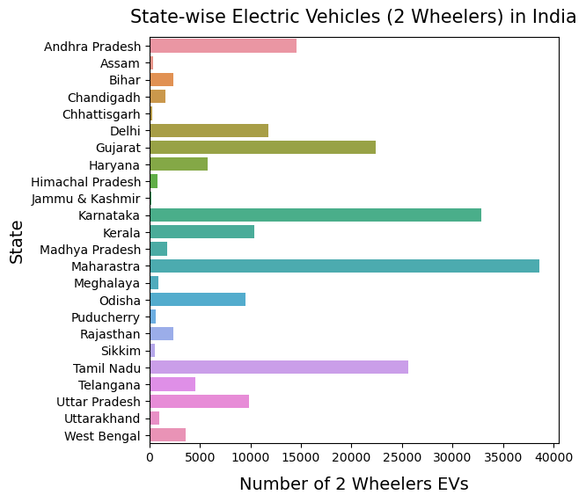

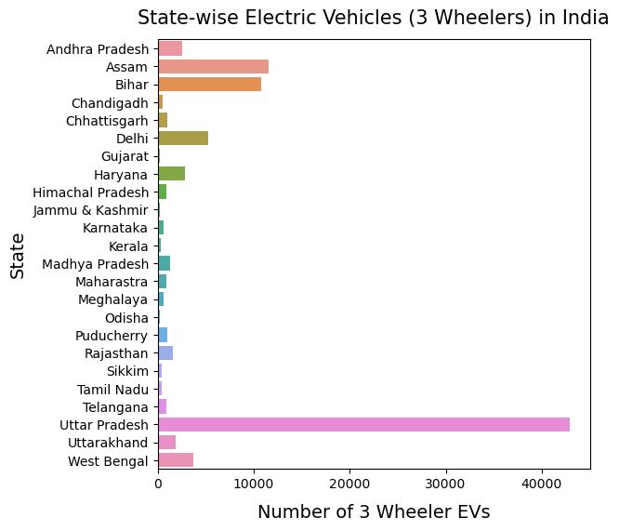

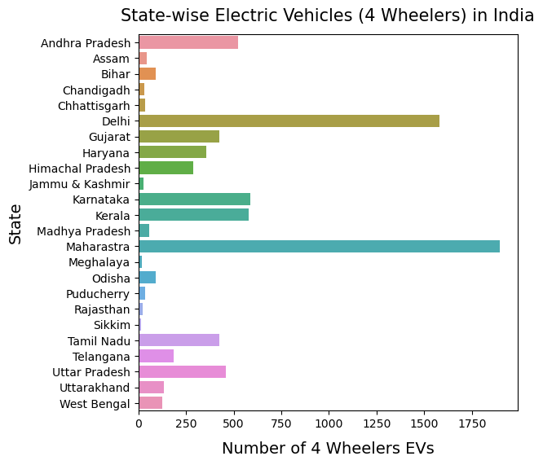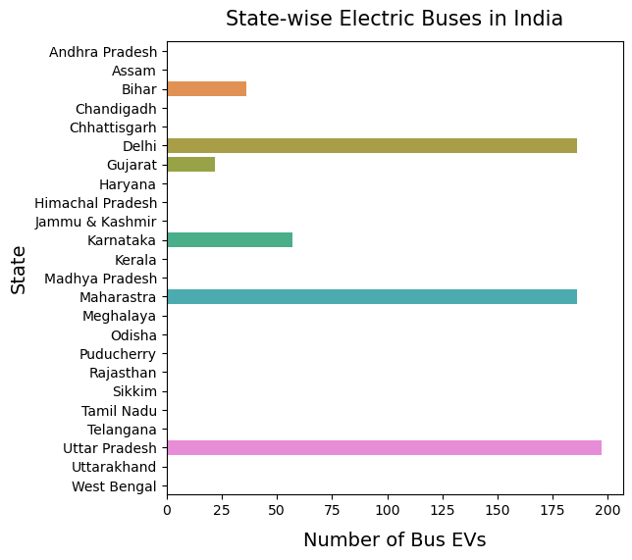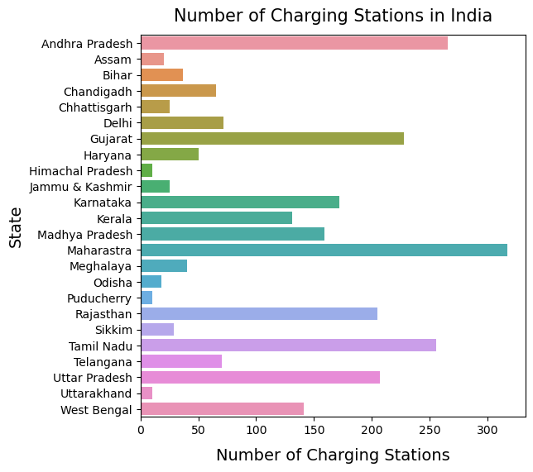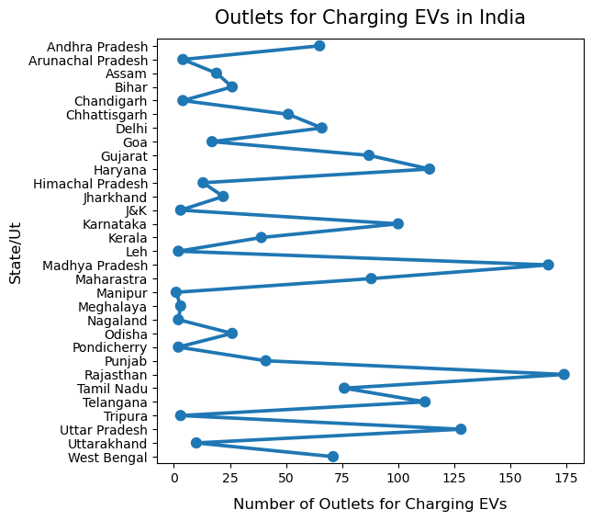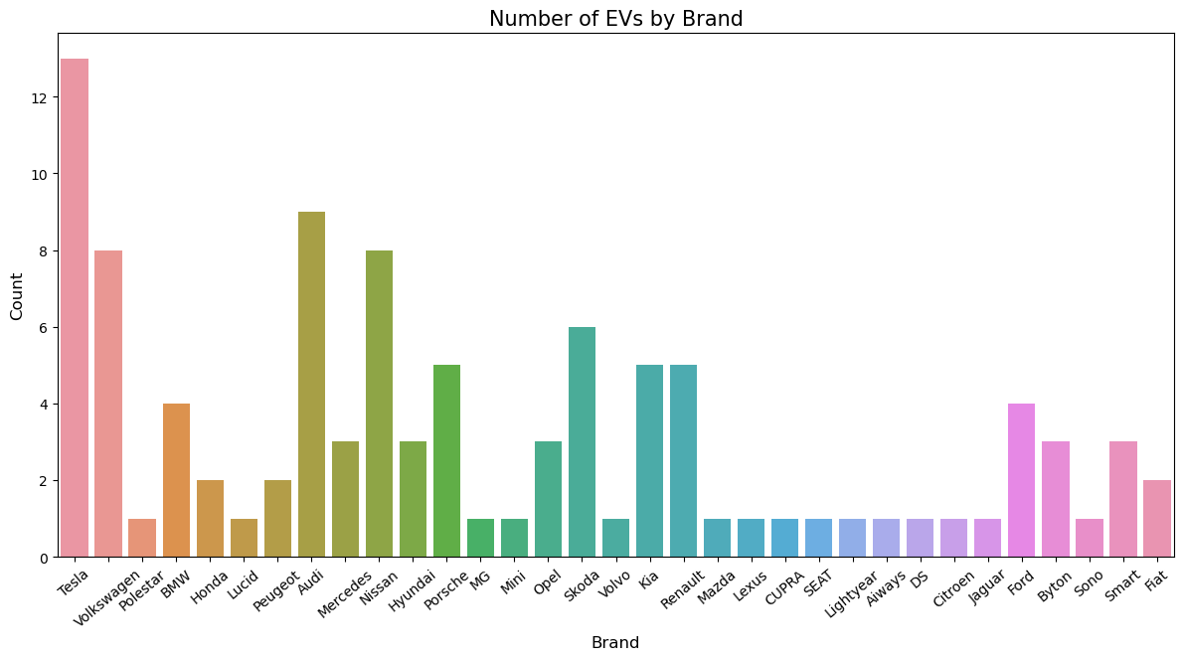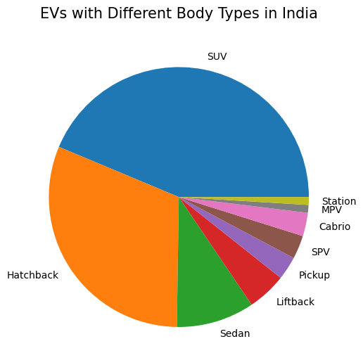

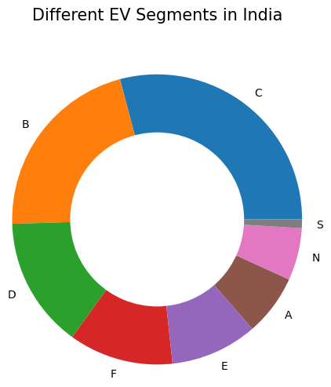

## **Customizing Market Mix**

To effectively target the identified segments in the Electric Vehicle (EV) market in India, it is essential to customize the marketing mix. The marketing mix comprises the four Ps: product, price, place, and promotion. Here's how the marketing mix can be customized for the EV market:

**1. Product:**

* Develop a diverse range of EV models to cater to different segments, including two-wheelers, three-wheelers, and four-wheelers. Focus on features that resonate with the target segments, such as advanced technology, connectivity options, safety features, and range capabilities.
* Offer flexible charging solutions, including home chargers, workplace chargers, and collaboration with charging infrastructure providers, to ensure convenient and accessible charging for customers.

**2. Price:**

* Set competitive pricing strategies based on the target segments. Consider factors such as affordability, value for money, and cost savings over the long term (lower operational and maintenance costs compared to conventional vehicles).
* Explore partnerships with financial institutions to offer attractive financing options, leasing programs, or subsidies to make EVs more affordable and accessible to a broader customer base.

**3. Place:**

* Establish an extensive distribution network in key target regions, focusing on urban centres and areas with high EV adoption potential. This includes setting up dedicated showrooms, experience centres, and partnerships with dealerships.
* Collaborate with strategic partners, such as ride-hailing platforms, fleet operators, and public transportation agencies, to increase the availability of EVs in the market and promote their usage.

**4. Promotion:**

* Create targeted marketing campaigns that emphasize the environmental benefits, cost savings, and technological advancements of EVs. Utilize various channels, including digital marketing, social media, print media, and television, to reach the target segments effectively.
* Leverage influencer marketing and partnerships with sustainability-focused organizations to generate awareness and credibility.
* Educate consumers about government incentives, tax benefits, and subsidies available for EV adoption, showcasing the long-term economic and environmental advantages.
* Additionally, it is crucial to continuously monitor and adapt the marketing mix based on consumer feedback, market trends, and competition. Regularly evaluate the effectiveness of marketing strategies through data analysis and customer insights to refine and optimize the marketing mix for better targeting and penetration in the EV market.

**Potential customer base**

To calculate the potential profit in the early market for business markets, you need to estimate the potential customer base and multiply it by your target price range. Here's how you can approach this calculation:

**1. Identify the Potential Customer Base**:

* Conduct market research and analysis to determine the size of your target market in the early stage.
* Consider factors such as the industry size, geographic scope, and market trends to estimate the number of potential customers who would be interested in your product or service.
* Use data from industry reports, market surveys, competitor analysis, and customer profiling to arrive at a reasonable estimate of the potential customer base.

**2. Determine Your Target Price Range**:

* Set a target price range for your product or service based on factors such as production costs, market demand, value proposition, and competition.
* Consider the price sensitivity of the target market and align your pricing strategy with the perceived value of your offering.

**3. Calculate Potential Profit:**

Multiply the estimated potential customer base by your target price range to calculate the potential profit in the early market.

For example, if the estimated potential customer base is 500 businesses and the target price range is $1,000-$1,500, the potential profit would be:

Potential Profit = Potential Customer Base * Target Price Range

= 500 * ($1,000-$1,500)

= $500,000-$750,000

It's important to note that this calculation provides an estimate and the actual profitability can vary based on market conditions, customer adoption rates, competition, and other external factors. It's advisable to continuously monitor and update your estimates as you gather more data and insights from the market.

**Optimal Market Segments**

Based on the market research and segmentation analysis conducted, the most optimal market segments to target in the EV market in India are:

**1. Urban Commuters:**

This segment consists of individuals residing in major cities who heavily rely on daily commuting. They are environmentally conscious and seek efficient and sustainable transportation options. Targeting this segment with electric two-wheelers and compact electric cars can be highly beneficial.

**2. Fleet Operators:**

Fleet operators, including ride-hailing companies, delivery services, and corporate fleets, are increasingly adopting electric vehicles to reduce operational costs and carbon footprint. Offering customized electric vehicle solutions, such as electric fleet packages or commercial electric vehicles, can attract this segment and provide a significant market opportunity.

**3. Government and Public Sector:**

The Indian government has been actively promoting the adoption of electric vehicles through various policies and incentives. Targeting this segment involves collaborating with government entities, public transportation authorities, and municipal corporations to supply electric buses, taxis, and other public transportation solutions. This segment offers a substantial market potential due to the scale of government initiatives and the need for sustainable public transportation options.

**4. Luxury Segment:**

High-income individuals who value luxury, performance, and exclusivity can be targeted with premium electric vehicles. This segment is willing to invest in high-end EVs that offer advanced features, cutting-edge technology, and superior driving experiences. Customizing EVs for this segment can yield higher profit margins and brand recognition.

**5. Rural Mobility:**

The rural segment represents an emerging market for EVs, particularly for e-rickshaws and electric tractors. Targeting rural areas with affordable and durable electric vehicles suited for agricultural and transportation purposes can tap into this growing market. Collaborating with local government bodies, cooperatives, and agricultural associations can help penetrate this segment effectively.

### These market segments have been identified as the most optimal based on their size, growth potential, and alignment with the key trends and demands in the EV market in India. However, it's essential to continually monitor the market dynamics, competition, and consumer preferences to adjust strategies and seize emerging opportunities.